# AI ASSIGNEMNT -6.1

K SRIMANI

2403A51275

BATCH-12

**TASK-1**

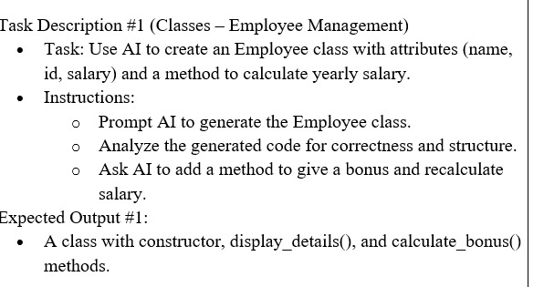

**PROMPT:**

Create an Employee class with attributes name, id, and salary. Add methods to display details, calculate yearly salary, and apply a bonus to update the salary.

**CODE:**

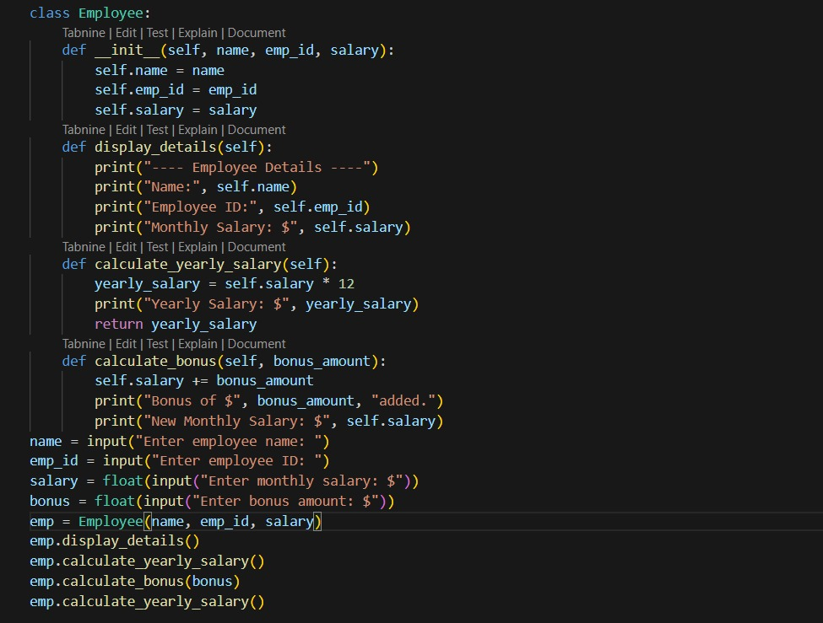

**OUTPUT**:

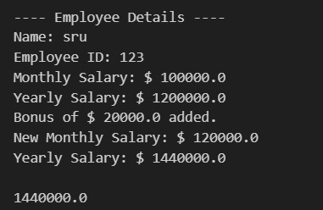

**TASK-2**

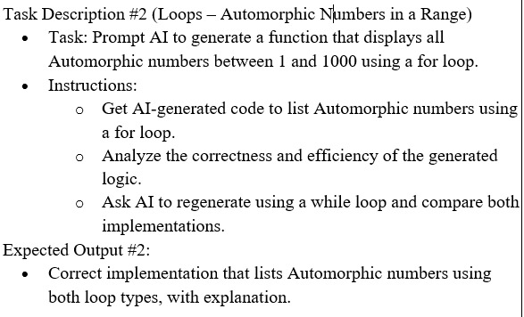

**PROMPT:**  
Write a function to print all Automorphic numbers between 1 and 1000 using a for loop, and then rewrite it using a while loop.

**CODE & OUTPUT:**  
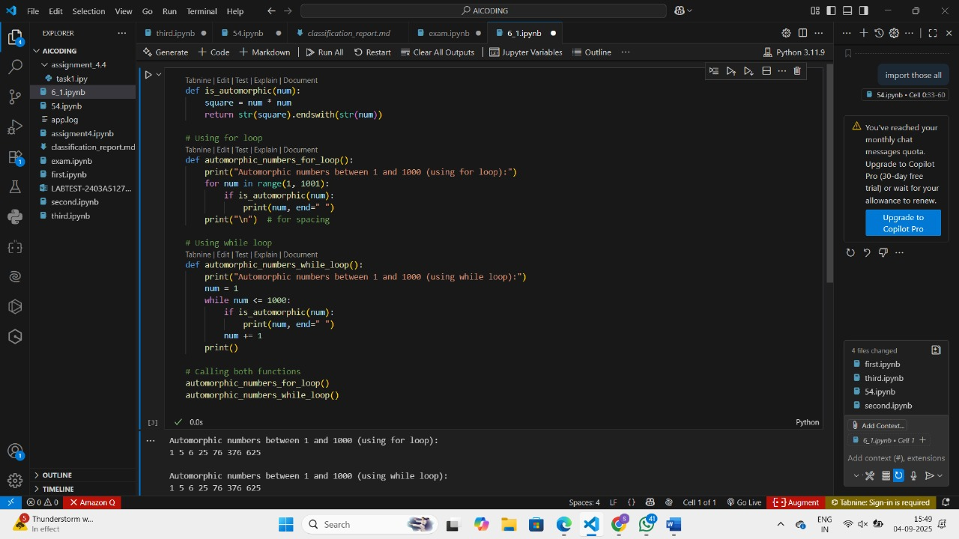

**TASK-3:**

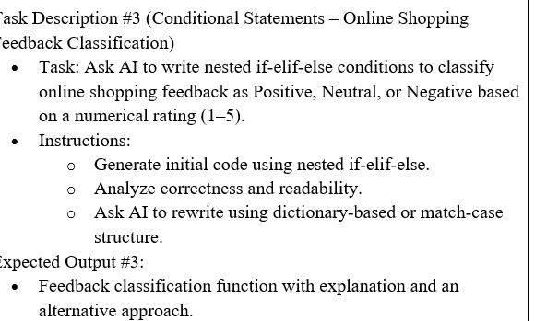

**PROMPT:**  
Write a function using nested if-elif-else to classify ratings (1–5) as Positive, Neutral, or Negative. Then rewrite it using a dictionary or match-case.

**CODE:**

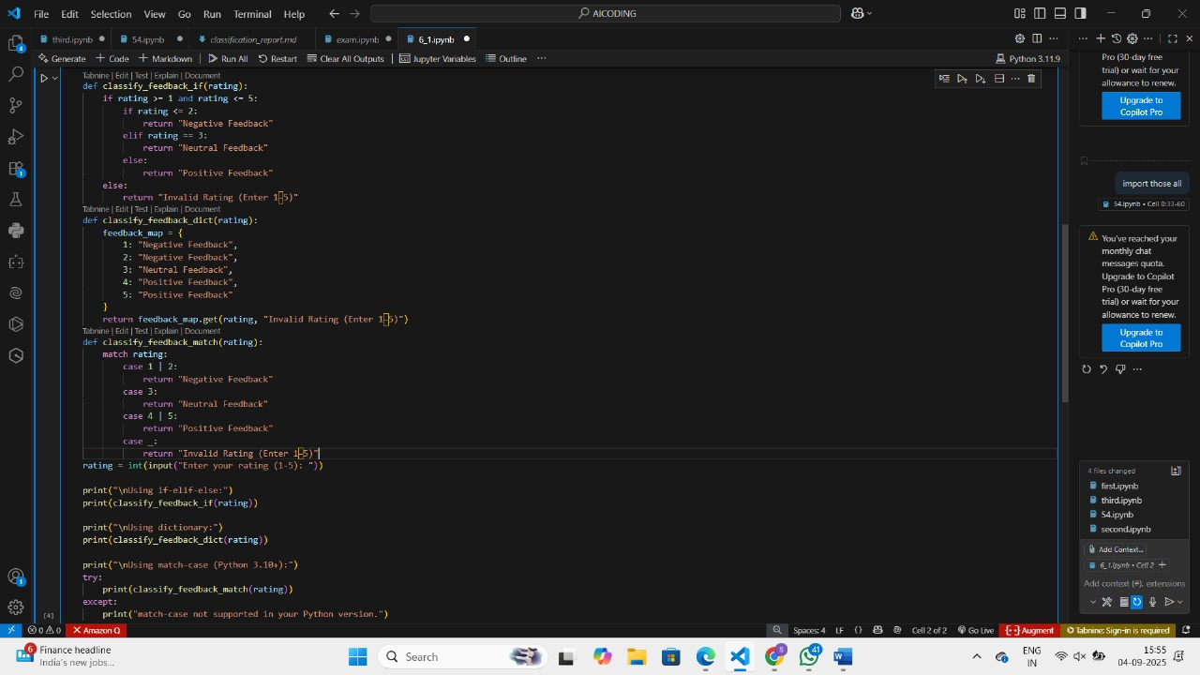

**OUTPUT:**

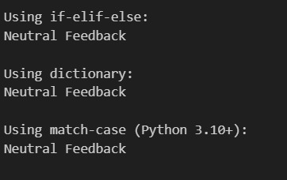

**TASK-4:**  
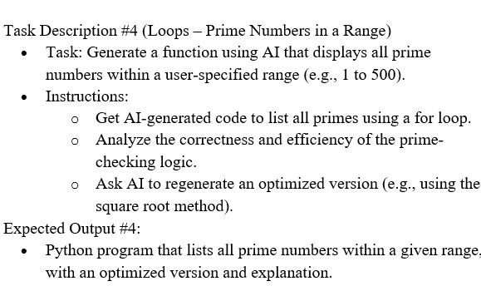

**PROMPT:**

Write a function to display all prime numbers within a given range using a for loop. Then improve it using the square root optimization.

**CODE:**  
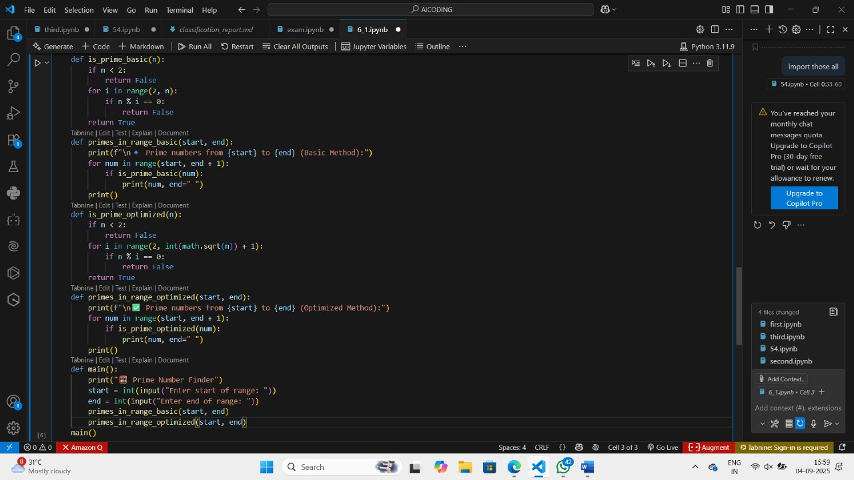

**OUTPUT:**

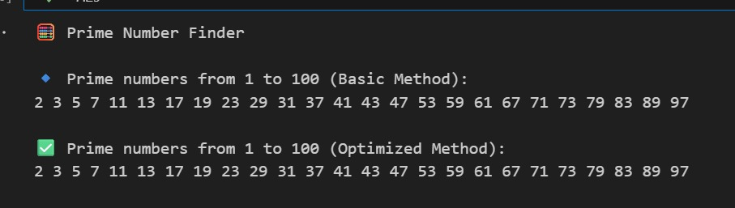

**TASK-5:**

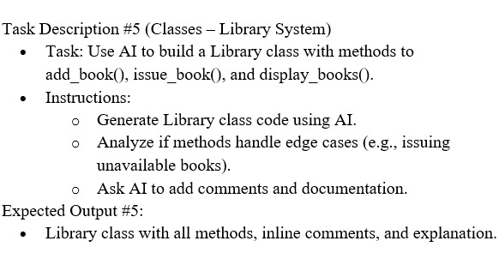

**PROMPT:**  
Build a Library class in Python with methods to add books, issue books, and display available books. Make sure to handle unavailable books and add comments.

**CODE & OUTPUT:**

